Sprint 1 — Filter & Search Evidence
Search and filter ErasmusIntern for suitable roles
Filters Applied
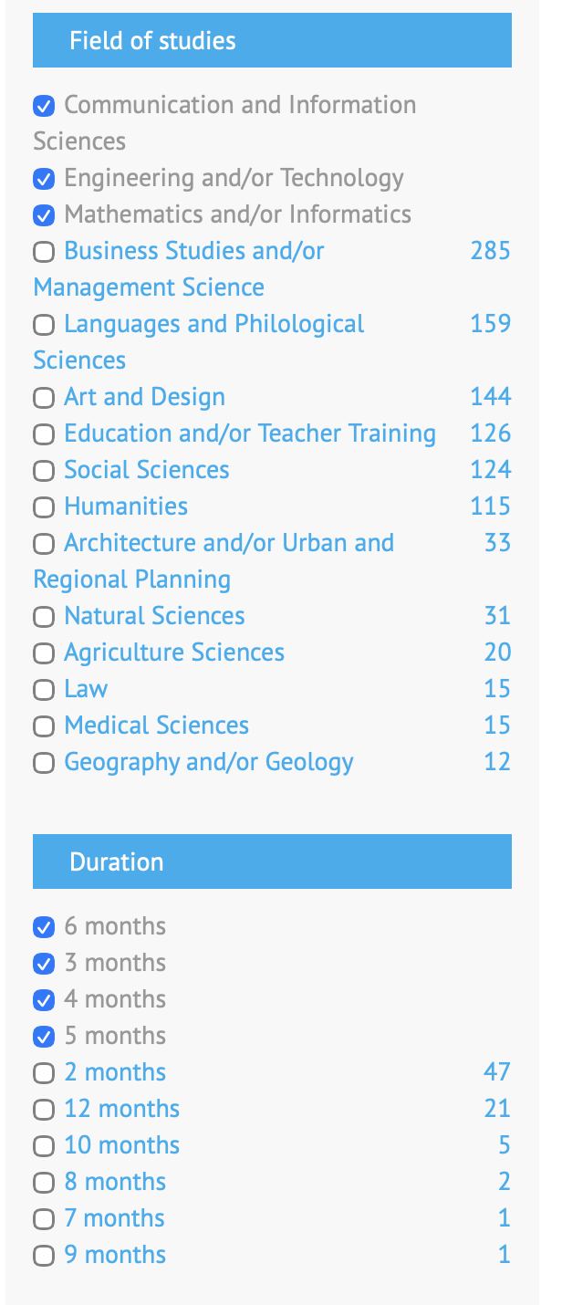
Field of study (Communication and Information Sciences; Engineering and/or Technology; Mathematics and/or Informatics) and duration (3, 4, 5, 6 months) filters ticked on ErasmusIntern.org.
Listing 1 — greentech.training
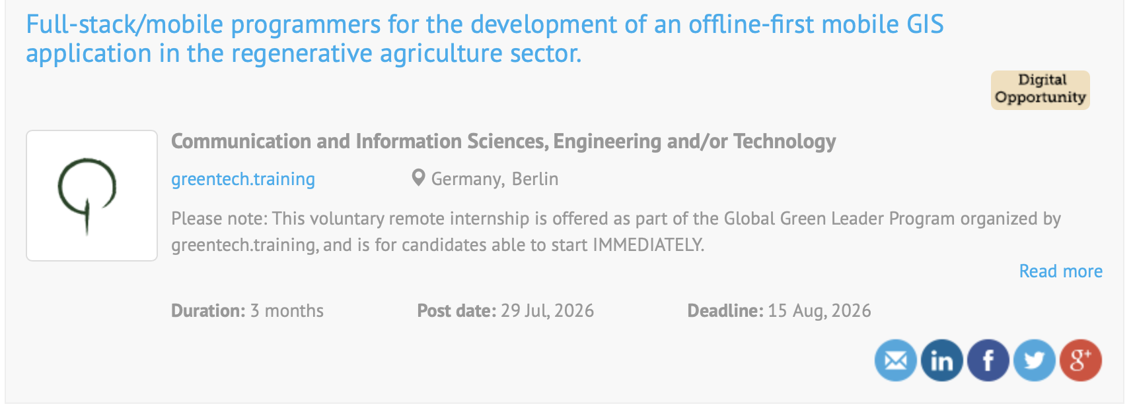
Full-stack/mobile programmers role — offline-first mobile GIS application, regenerative agriculture sector.
Listing 2 — Expat Globe
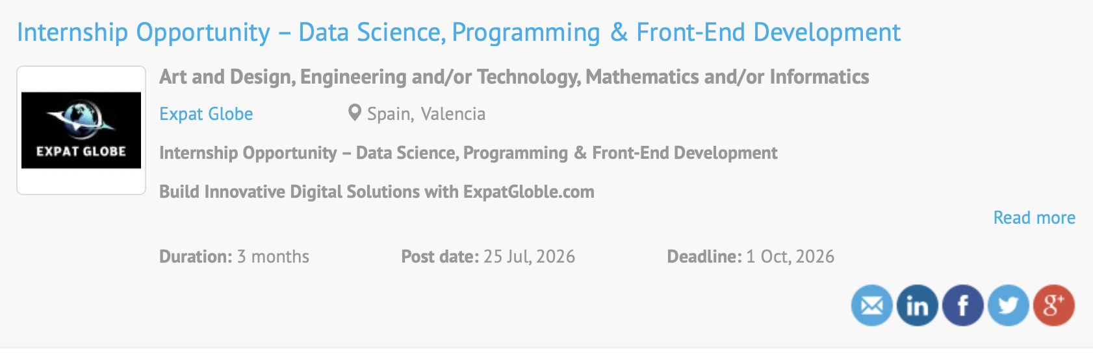
Internship Opportunity — Data Science, Programming & Front-End Development.
Listing 3 — Apollo Green Solutions
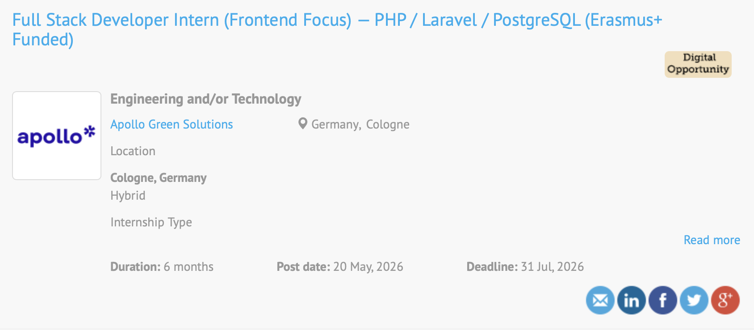
Full Stack Developer Intern (Frontend Focus) — PHP / Laravel / PostgreSQL, Erasmus+ funded.

